Topcoder NodeJS – DocuSign Callback API v1.0 Deployment Guide

Revision History
Author | Revision Number | Date
kurtrips | 1.0 | 2014/03/26
Deployment Instructions 3
1.Submission Strategy 3
2.Organization of Submission 3
3.Application Setup 4
3.1.Preconditions 4
3.2.Build Script Setup 4
4.DocuSign Setup 5
4.1.Templates Setup 5
4.2.Docusign Connect Setup 8
5.Database setup 10
6.Configurations 10
7.Deployment Instructions 10
10.Resource Contact List 16

Deployment Instructions

Submission Strategy
There are a few problems in the development of this contest. What these problems are and how they are solved in this submission is explained in this section.

Problem 1: actionhero by default is not able to accept text/xml content type. However Docusign Connect uses XML to publish enevelope info to the callback url. It looks like there is no way to “configure” actionhero to accept xml, and the only way looks like modifying its source code.
Solution 1 (Not Used): One possible solution is to fork actionhero and formidable and modify them to accept text/xml payloads. On a cursory look, it does not look too difficult. But the problem will arise on how to integrate the modified actionhero with the rest of the TC-API. This can be quite tedious.
Solution 2 (Used): Another possible solution is to have an intermediary listener which will listen to the Docusign Connect envelope info, convert the XML to JSON and then call our actionhero action. The intermediary is just a pure node.js server listening on another port. Since it pure node.js, it can accept any payload in any format. This strategy is used in this submission because it is much simpler than forking actionhero.

Problem 2: Given that we will use a pure node.js listener (as described above), it needs to listen on another port than actionhero. While on the production system, opening ports will not be a problem, on heroku only one port can be used. There is no way of opening more than 1 port. The same problem exists on TC VM where only port 80 is open and requests to open ports are conveniently ignored!
Solution: We will use 2 heroku deployments, one for the actionhero API (as usual) and one for our custom docusign callback listener. In the submission, the docusign_callback directory contains the code for the listener and also contains script to deploy it onto heroku.

You can now got straight to section 7 and follow the deployment instructions strictly in order.

Organization of Submission
The folder structure (the root directory of the submission is referred as the <base> throughout the document)
Name | Description
tc-api/ | Main application source code of this assembly.  Contains only new or changed files.
tc-api/docusign_callback | Application source code for the docusign callback listener
tc-api/doc/Module Assembly - TopCoder Callback API v1.0.doc | This file.

Application Setup

Preconditions
- Linux 64bit System (preferably the Ubuntu 10.04), which is used by Heroku stack for Nodejs), with development tool, such as g++, maker.
- NodeJS 0.10.21 http://nodejs.org/
- Git
- Heroku Account and Toolbelt
  - Signup a Heroku account in https://api.heroku.com/signup/devcenter with your email address.
  - Download the Heroku Toolbelt from https://toolbelt.heroku.com, and make sure the Heroku CLI is working in your environment by typing the “heroku help”.
  - Login your Heroku account by typing the “heroku login”.
This requires you to input your email and password, and then finally it will upload your public SSH key to the server so that you don’t have to provide your credential during the subsequent commands.
If you have a “Permission denied (publickey)” error during deployment, you can use “heroku keys:add” to add the public key to the remote repo as described here.

Build Script Setup
Three BASH scripts are used to ease the deployment.
- deploy/development.sh
It helps to launch the application locally.
It simply exports the configured environment variables and then launch the Node.js application.
- deploy/heroku.sh
It helps to deploy the application onto the Heroku cloud.
It has command line switches.
Switch | Description
clean | It cleans the current repository information by simply removing the .git folder.
commit | It initializes the local repository and commits all the current project files, if the current directory is not a GIT repo yet; or commit all the changes to the local repository, if the current directory is already a GIT repo.
create | It creates a Heroku app for the current logged-in Heroku account.  This app will only be used if it is created when the current local GIT repo has not yet setup the remote repo of name “heroku”.  If your local repo has already setup “heroku” remote for an existing app, this app will not be picked as the target app for other Heroku commands. If you want to create an new Heroku app and use it as the target app in this case, you can clean and re-initialize the current local repo first, or you explicitly rebase it to the new Heroku app.
config | It exports all the configured environment variables to the target Heroku app.
push | It pushes the current committed version to the “heroku” remote.
launch | It launches one Heroku dyno to run the target app.
all | It will execute all other steps in the order: “clean”, “commit”, “create”, “config”, “push”, and then “launch”.
deploy | It only executes the steps to deploy the projects to the Heroku cloud: “config”, “push”, and then “launch”.  It assumes the code has been committed to the local repo, and the local repo has setup the “heroku” remote for the target app.

- docusign_callback/heroku_setup.sh
It helps to deploy the standalone Docusign Callback listener onto the Heroku cloud.

DocuSign Setup

Templates Setup
First of all you will need to create your developer account at https://www.docusign.com/developer-center/get-started.
Now follow these steps:
- Login to DocuSign https://demo.docusign.net/Member/MemberLogin.aspx

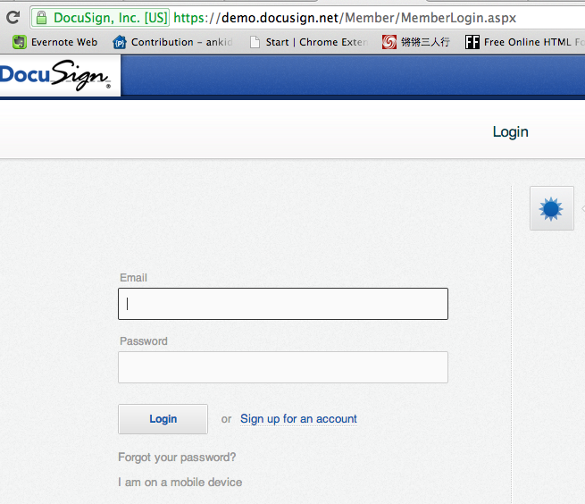

- Click “Manage”, and then click “My Template” in left bottom:
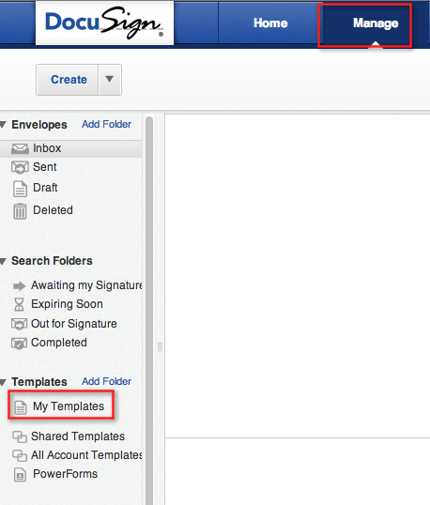

- Download http://apps.topcoder.com/forums/?module=Thread&threadID=812742&start=0
Then unzip it, you will find all the 5 xml files in folder docusign-templates that need to test
Click “Actions”, select “Upload Template(s), upload them one by one to docusign website:
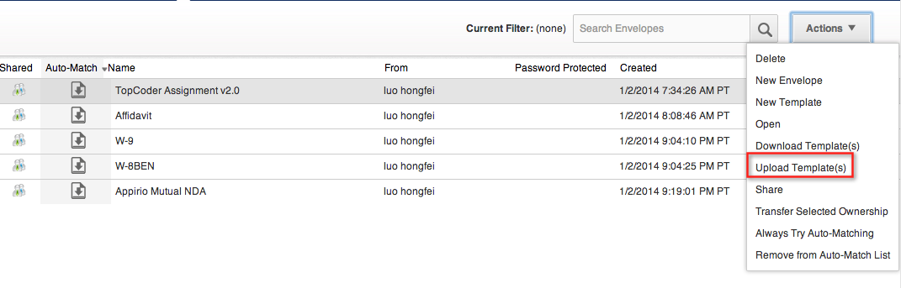After uploading the xml, we can see the 5 documents are in the docusign website that we can test it later.

You need to change the template ids in the config.js to the ones in your developer account.
To view the template ids in your account, click the Manage tab at the top and then click Templates/My Templates in the sidebar. This will bring you to this page:
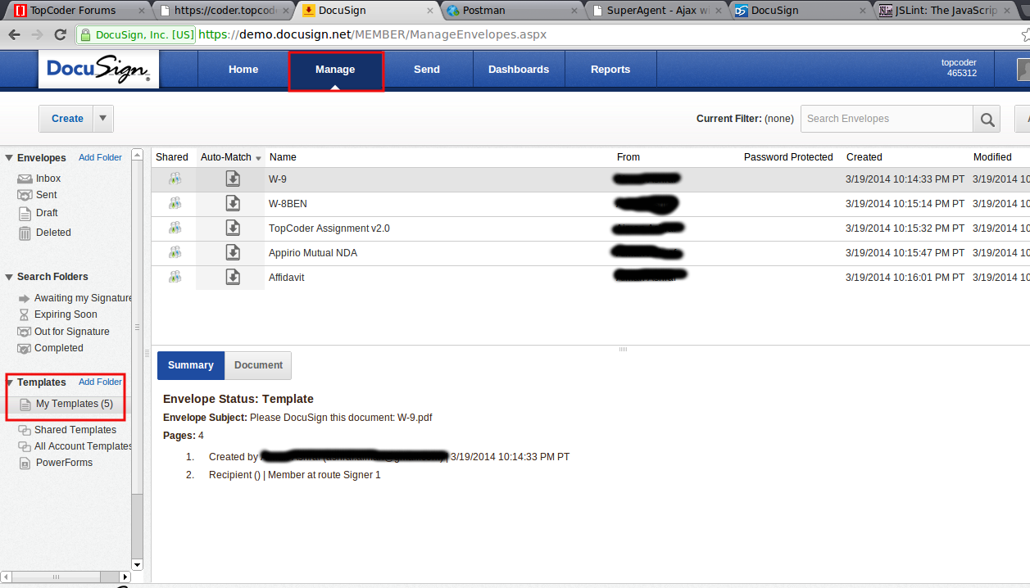
Then double click on the name of the template which will get you to this page. The template id is highlighted. This needs to be done for each template.
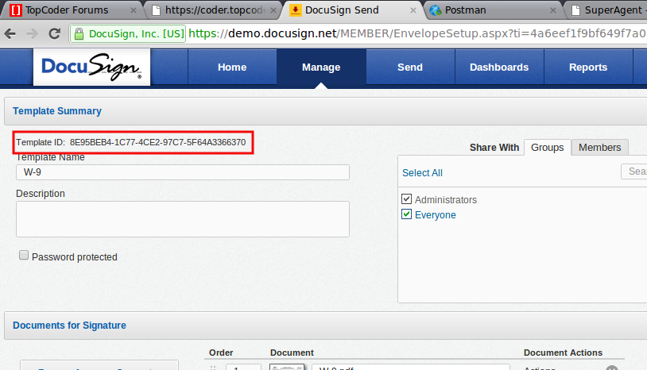
Then open config.js and set the template ids to your values.
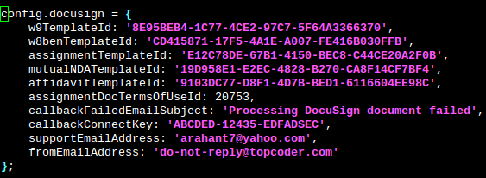

Docusign Connect Setup
Go to Preferences → Connect → Add Configuration
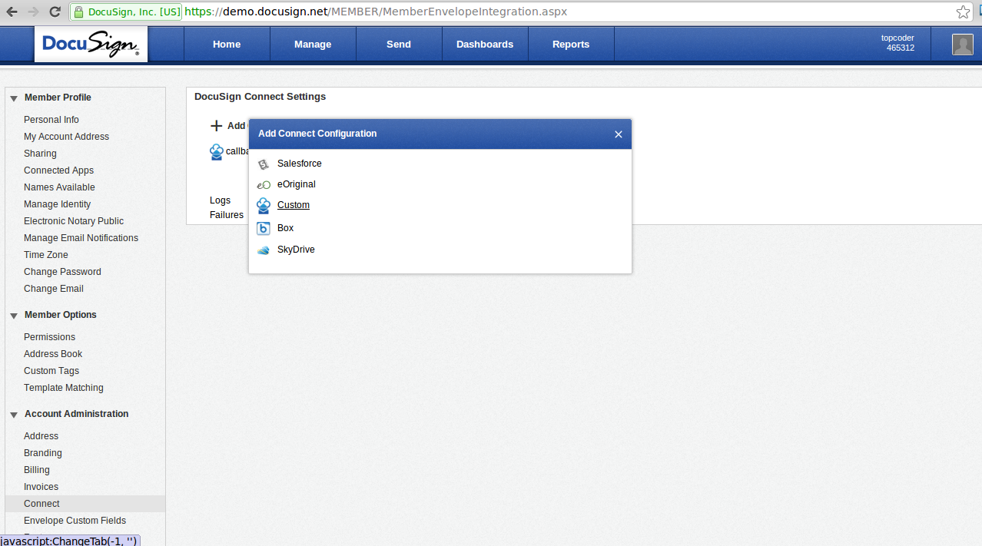
Now set the URL to publish to the heroku URL for the docusign callback listener (shown in red). The connectKey parameter must be set to an arbitrary value but the same value must be present in config.docusign.connectKey in config.js.
Also make sure that the Allow Envelope publish, Envelope Completed and All Users Integrated checkboxes are checked as shown. Once done, click on Save
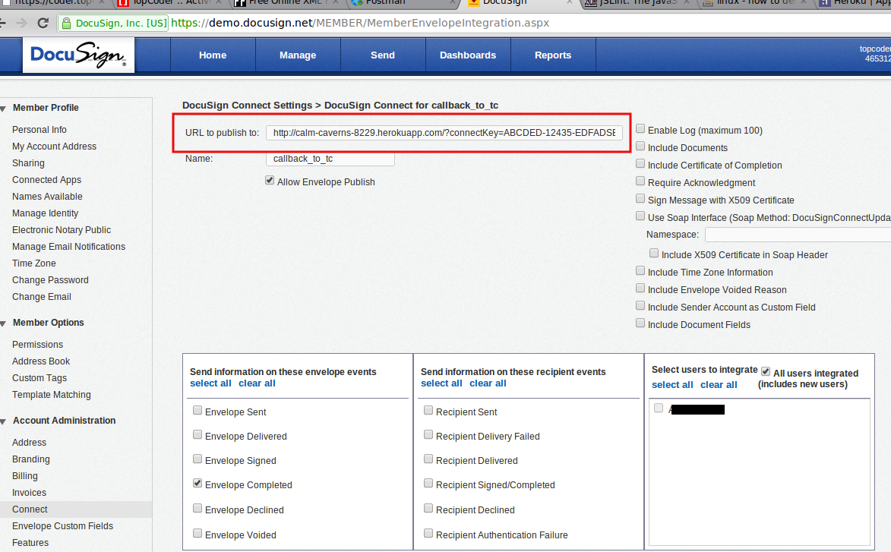

Database setup
There is no database setup required for this contest.
NOTE: The docusign_envelope table might not exist in your VM. If it does not, you will need to create it. Its DDL is found at https://coder.topcoder.com/internal/database/scripts/trunk/informixoltp/01_informixoltp_main_schema.sql

Configurations
In “tc-api/deploy/development.sh”, you need to set VM_IP with your actual VM IP.
VM_IP=54.204.253.124

No changes are required to tc-api/deploy/heroku.sh.

In this contest, a new config.docusign object is added to the config.js. Its fields are described below:
Configuration | Description
xxTemplateId | There are 5 such configuration elements.  W9TemplateId  w8benTemplateId  assignmentTemplateId  mutualNDATemplateId  affidavitTemplateId  Each of these should point to the corresponding template id in the Docusign System
assignmentDocTermsOfUseId | The terms of use id for the Assignment Template
callbackConnectKey | The callback connect key which is configured in the Docusign Connect system. See the highlighted in red part of second screenshot in section 4.2. The values must match.
callbackFailedEmailSubject | The subject of email to send when callback fails unexpectedly
supportEmailAddress | The email of the support staff, to which the email will be sent.
fromEmailAddress | The from address of the email.

Deployment Instructions
The deployment in this contest is a bit convoluted, so follow it exactly in order.
- Install heroku on your system (if not already) as described in section 2
- Setup Docusign templates as described in section 4.1
- Setup database as described in section 3.
- Run git clone https://github.com/cloudspokes/tc-api
Checkout to commit c82d0f290c7c9456c6ea04c198875ced8f4fcbc2
- Copy all files from submission/tc-api to checked out tc-api and override all files
- Replace VM_IP and setup the configuration as described in section 6.
- Run npm install
- Install the tc-api onto heroku :
  - Run script to export variables
. deploy/development.sh
  - Run the script to deploy to heroku
chmod +x deploy/heroku.sh
. deploy/heroku.sh all
  - After running the script will be printed something like
http://intense-beach-7489.herokuapp.com/ deployed to Heroku
- Setup the standalone docusign callback listener and install it onto heroku
  - cd docusign_callback
  - Run npm install
  - Set the API endpoint that our standalone listener must call. Here the base url is the heroku url for the tc-api created above in step 8
export DOCUSIGN_CALLBACK_ENDPOINT=http://intense-beach-7489.herokuapp.com/v2/terms/docusignCallback
  - Run the heroku setup script
chmod +x heroku_setup.sh
. ./heroku_setup.sh
  - After running the script will be printed something like
http://calm-caverns-8229.herokuapp.com/ deployed to Heroku

- Follow section 4.2 to setup Docusign Connect and point the URL to standalone listener heroku url. So in our case it will be
http://calm-caverns-8229.herokuapp.com/?connectKey=ABCDED-12435-EDFADSEC

- Verification by tests
  - Js lint
Install the node-jslint in your local environment globally by “sudo npm install jslint -g".
Check the following files under the <base>/tc-api
jslint -nomen actions/docusign.js
jslint -nomen docusign_callback/docusignCallbackListener.js
jslint -nomen config.js
jslint -nomen routes.js
jslint -nomen test/test.docusignCallback.js
jslint -nomen docusign_callback/test/test.docusignCallbackListener.js

  - Mocha
There are 2 tests. One for the Docusign Callback Action and one for the Standalone Docusign Callback Listener
    - Tests for Docusign Callback Action – These tests check that the Action performs properly given an incoming JSON request.

- Make sure the tc-api server is running, if not use npm start.
- Now, run
“node_modules/.bin/mocha test/test.docusignCallback.js”
- There are 8 tests which should all pass.
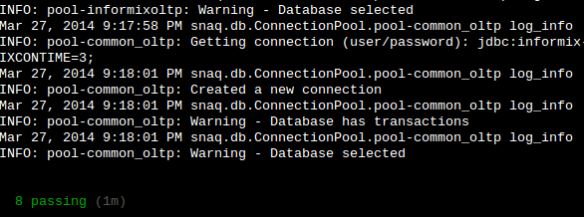
    - Tests for Standalone Docusign Callback Listener – These tests check that the standalone listener performs properly given an incoming XML request.

- cd docusign_callback
- unset DOCUSIGN_CALLBACK_ENDPOINT
(this is need so we can test on localhost)
- Use npm start to start the standalone listener. It will open on port 8081
- Make sure the tc-api server started in last step is still running, because the listener connects to the tc-api server.
- Now, run
“node_modules/.bin/mocha test/test.docusignCallbackListener.js”
- There are 4 tests which should all pass.
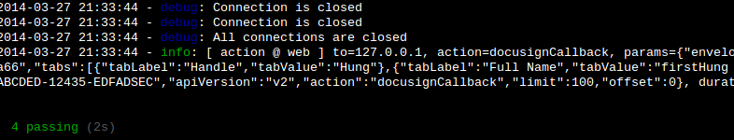

- Verification by pages
Please check apiary.apib for the updated docs.

Sample Workflow – Walkthrough
(section 7 must be complete before this walkthrough)

- Create new envelope in docusign. Go to Send → Choose An Online Document → My Templates → Select TopCoder Assignment v2.0 → Click Add
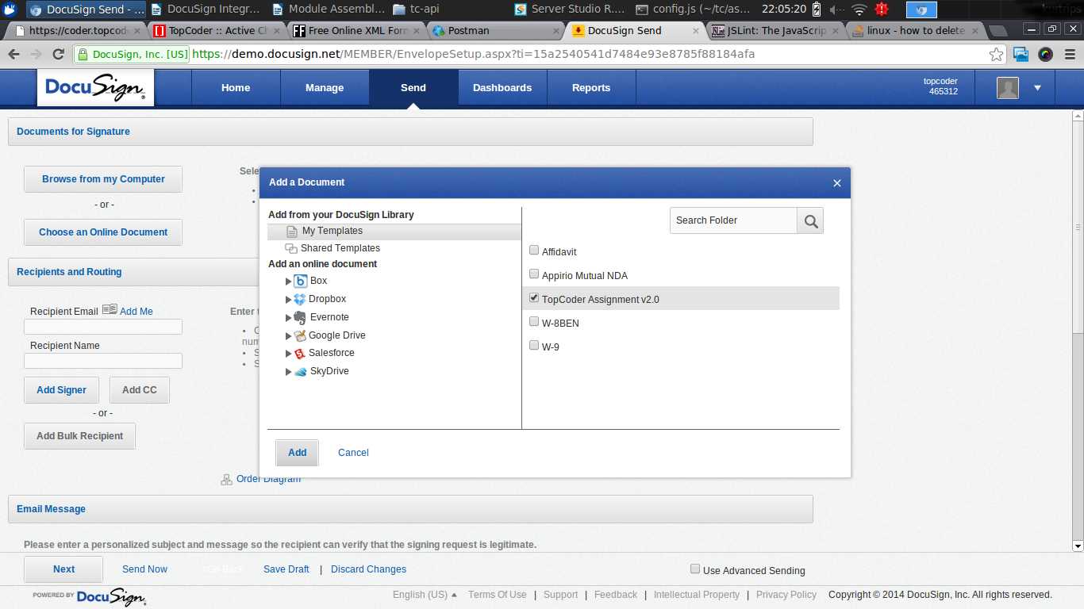

- Enter Email (your email) and some Name and click Send Now.
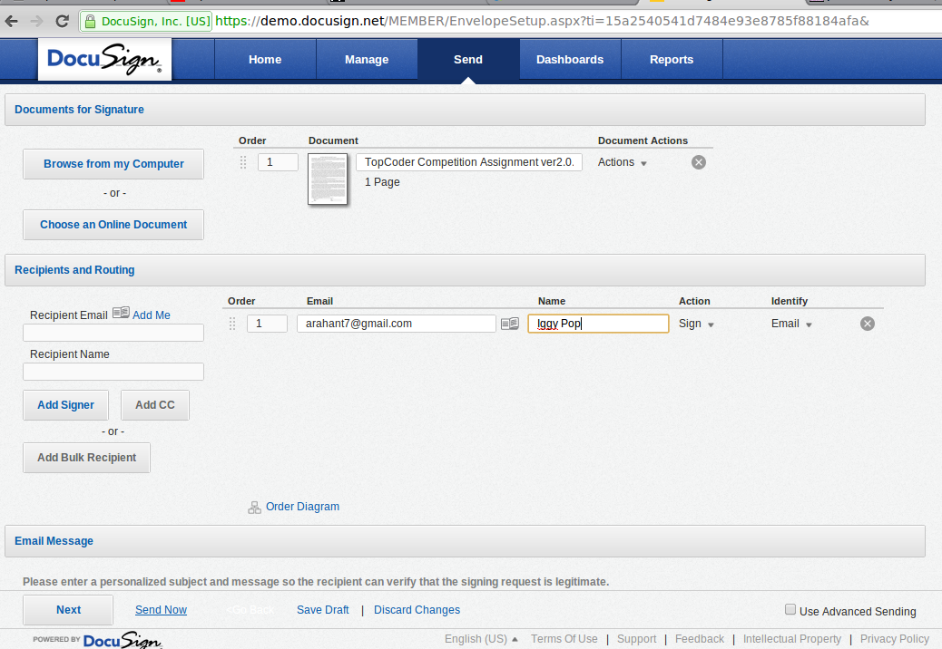

- Now you should receive the email. In the meantime, find out the envelopeId, by clicking on Down Arrow (on extreme right of row) and then 'Export Selected as CSV'
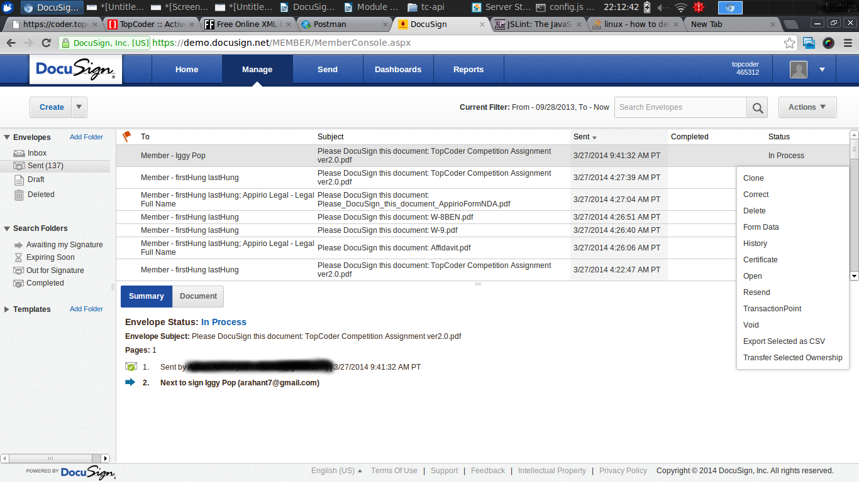
- Open the CSV and the first column is the envelopeId. Now we will insert the record in DB manually (another contest does this but it is out of scope). I use Server Studio for insert into DB. Makre sure the envelope_id is the one you just found and the template_id is the one in config.docusign.assignmentTemplateId
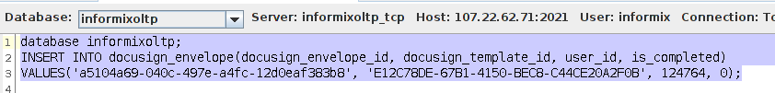
5. Now open the mail and click on the View Documents link. The document opens up. Now complete the fields and then click Confirm Signing.

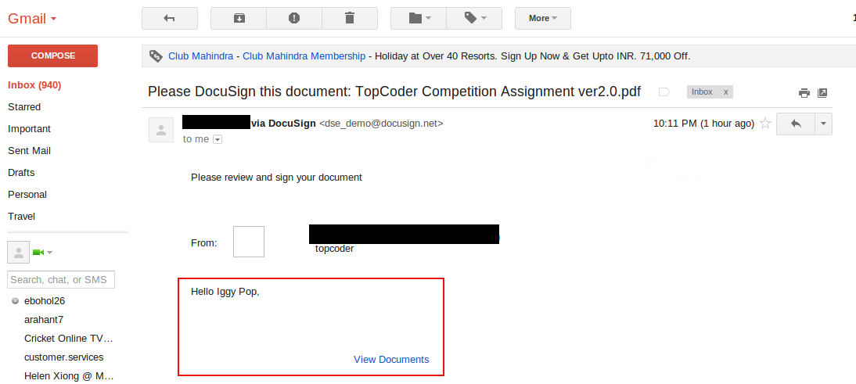
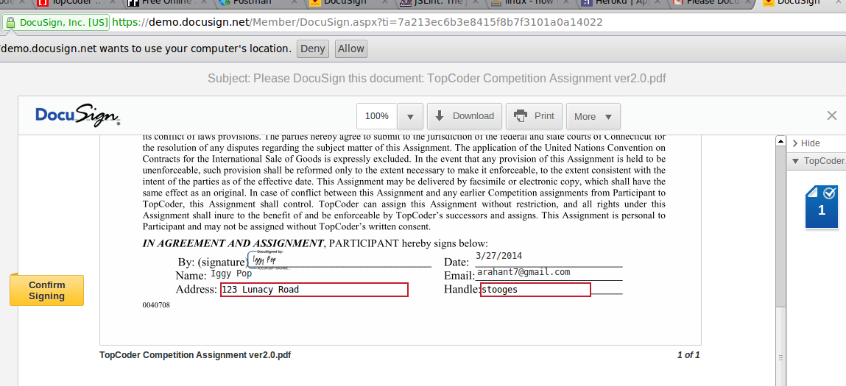

6. Wait about a minute before you run the following queries (change the envelope_id to yours)
SELECT * FROM docusign_envelope WHERE docusign_envelope_id = 'a5104a69-040c-497e-a4fc-12d0eaf383b8';
SELECT * FROM user_terms_of_use_xref WHERE user_id = 124764;
Notice the is_completed is now set to 1 and the user_terms_of_use_xref now has the entry. We are done!

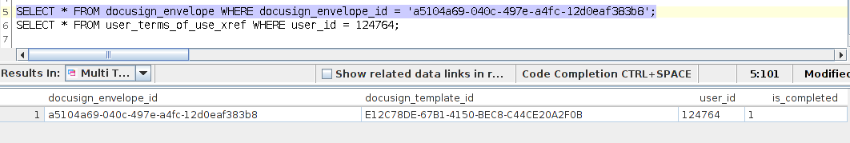
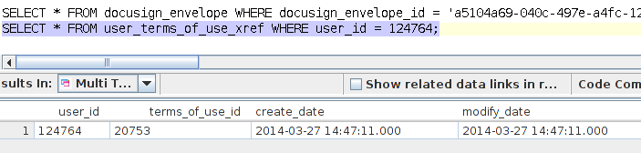

Support Email Demonstration

Emails are sent to the support staff only in case of unexpected errors. During expected errors, only logging is performed. This makes email demonstration a little difficult. One scenario where we can view email sending is when assignment terms of id is non existent.
- In config.js, set config.docusign.assignmentTermsOfUseId: 999999
- In deploy/development.sh, set TC_EMAIL_ACCOUNT and TC_EMAIL_PASSWORD to some account of yours. It has to be a gmail account.
- In config.js, set config.docusign.supportEmailAddress to some other email account of yours. This is where you will receive the email.
- . ./deploy/development.sh
- npm start
- node_modules/.bin/mocha test/test.docusignCallback.js (!some tests will fail!)

Here is a screenshot of an email received.
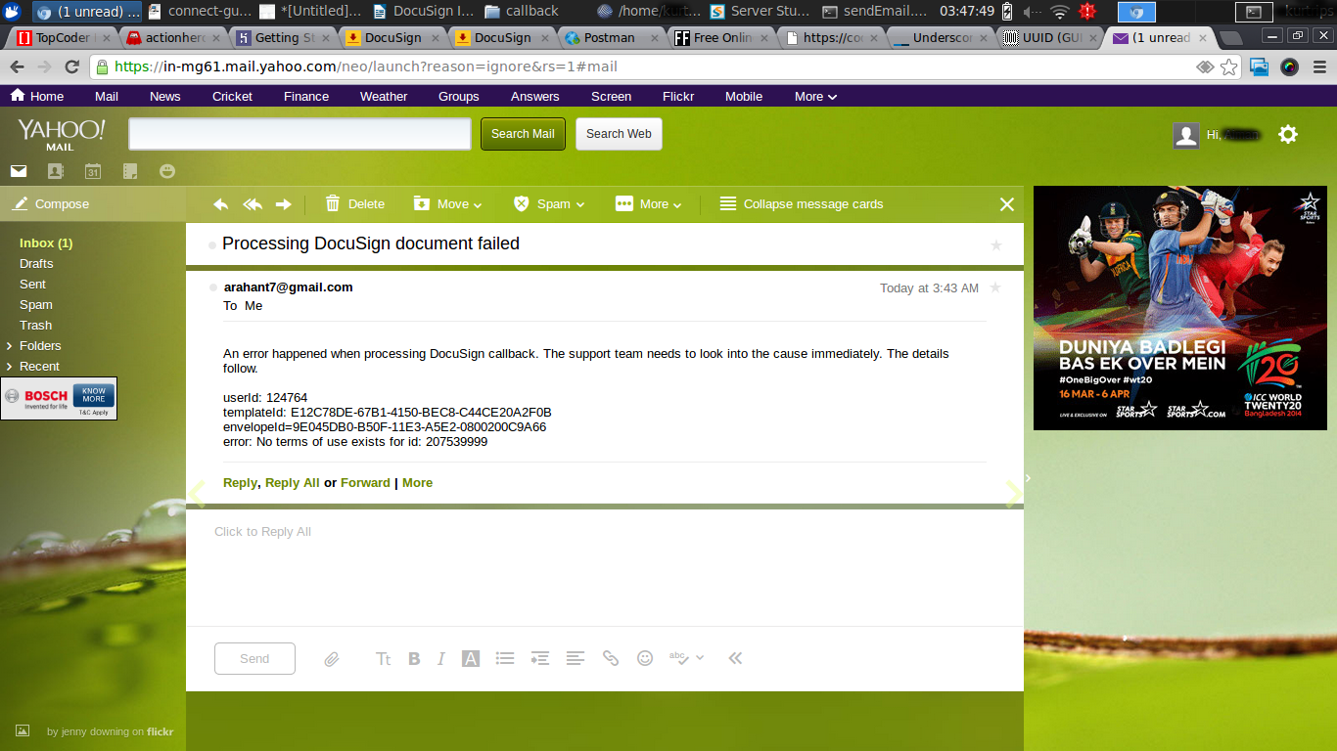

Resource Contact List
Name | Resource Email
TCSASSEMBLER

